Execute all the steps shown in video.
- Upgrade k8s cluster from 1.29 to 1.30 Version. Note: Document to upgrade cluster. https://devopscube.com/upgrade-kubernetes-cluster-kubeadm/

OVERVIEW (What you’ll do)
- Backup cluster
- Upgrade Control Plane:
  - kubeadm
  - control plane
  - kubelet + kubectl
- Upgrade Worker Nodes
- Verify cluster

STEP 0: Pre-checks (DO THIS FIRST)
kubectl get nodes
kubectl version
All nodes must be Ready
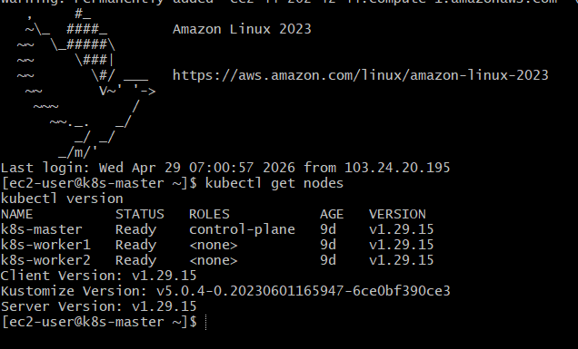
Backup (VERY IMPORTANT)
kubectl get all --all-namespaces -o yaml > backup.yaml
👉 Always backup before upgrade

STEP 1: Upgrade CONTROL PLANE (1.29 → 1.30)
🔹 1. Drain Master Node
kubectl drain <master-node> --ignore-daemonsets --delete-emptydir-data
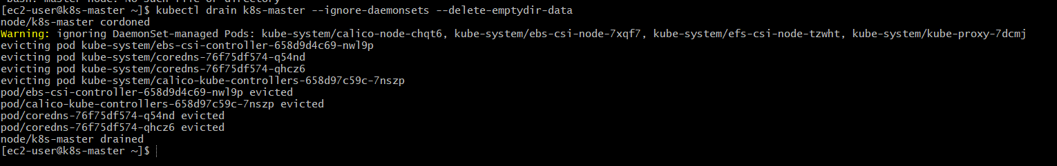

2. Upgrade kubeadm
sudo yum install -y kubeadm-1. 30
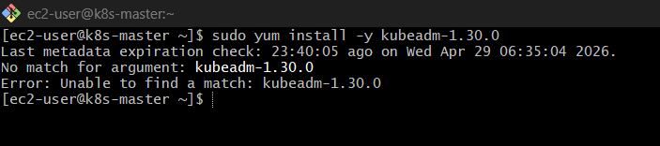

👉 If version not found, first update repo (one-time):

cat <<EOF | sudo tee /etc/yum.repos.d/kubernetes.repo
[kubernetes]
name=Kubernetes
baseurl=https://pkgs.k8s.io/core:/stable:/v1.30/rpm/
enabled=1
gpgcheck=1
gpgkey=https://pkgs.k8s.io/core:/stable:/v1.30/rpm/repodata/repomd.xml.key
EOF
sudo yum clean all
sudo yum makecache

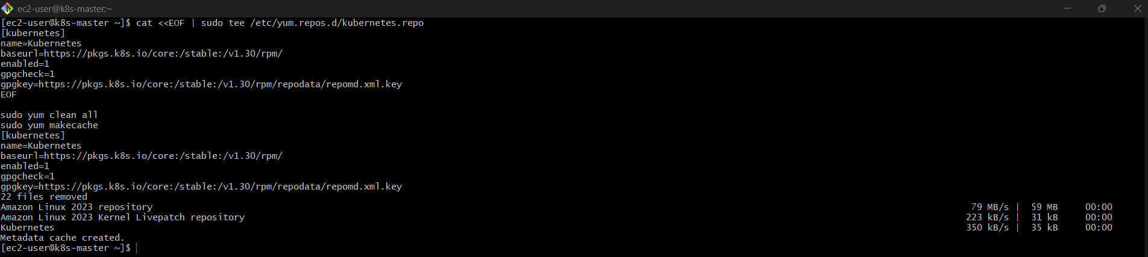

FIX STEP-BY-STEP (DO THIS EXACTLY)
🔹 Step 1: Verify kubeadm version
kubeadm version
👉 If it shows:
v1.29.x ❌
Then upgrade didn’t happen.

🔹 Step 2: Force correct repo (important)
sudo rm -f /etc/yum.repos.d/kubernetes.repo

Now recreate:
cat <<EOF | sudo tee /etc/yum.repos.d/kubernetes.repo
[kubernetes]
name=Kubernetes
baseurl=https://pkgs.k8s.io/core:/stable:/v1.30/rpm/
enabled=1
gpgcheck=1
gpgkey=https://pkgs.k8s.io/core:/stable:/v1.30/rpm/repodata/repomd.xml.key
EOF

🔹 Step 3: Clean cache (VERY IMPORTANT)
sudo yum clean all
sudo rm -rf /var/cache/yum
sudo yum makecache
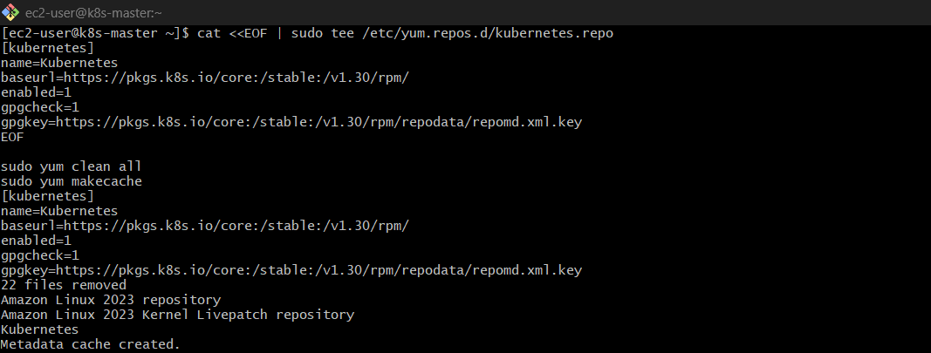

🔹 Step 4: Check available versions
yum list kubeadm --showduplicates | grep 1. 30
👉 You must see something like:
kubeadm.x86_64 1.30.x
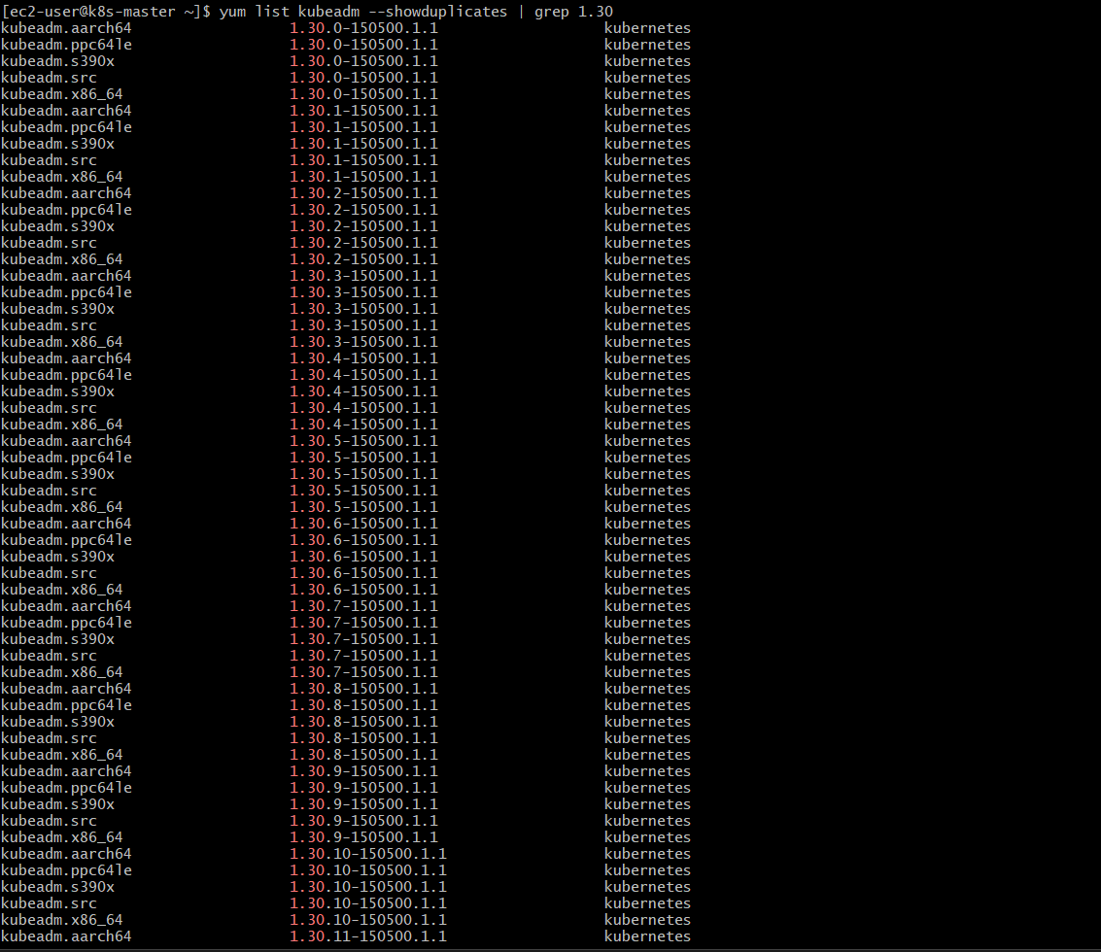
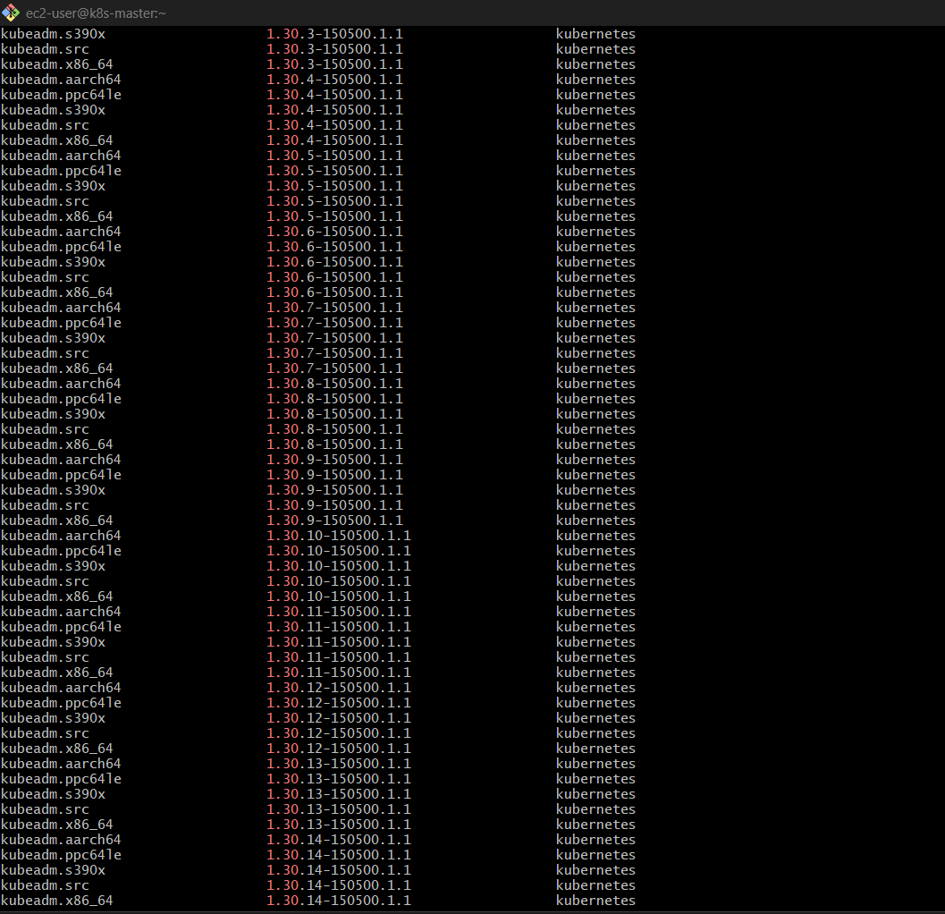
🔹 Step 5: Install correct version
sudo yum install -y kubeadm-1.30*
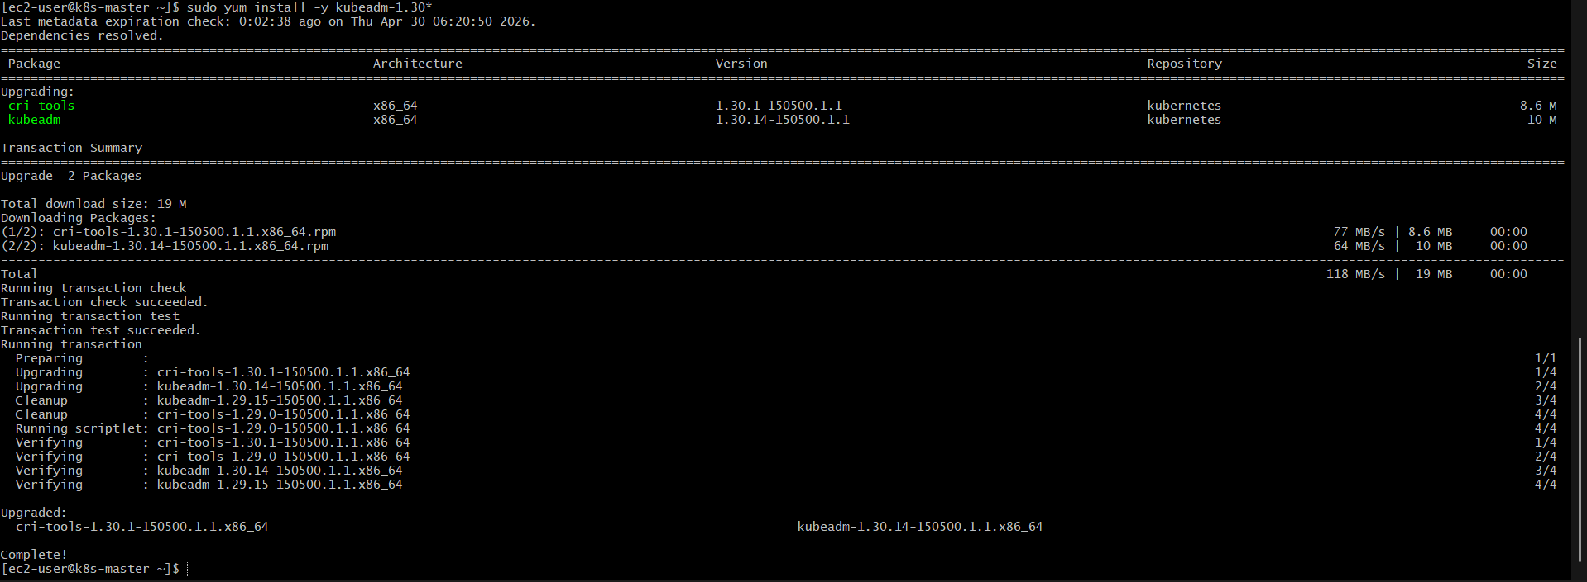

🔹 Step 6: Verify again
kubeadm version
👉 Now it should be:
v1.30.x ✅

🔹 Step 7: Now run upgrade plan again
sudo kubeadm upgrade plan
👉 Now you should see:
Upgrade to v1.30.x available ✅
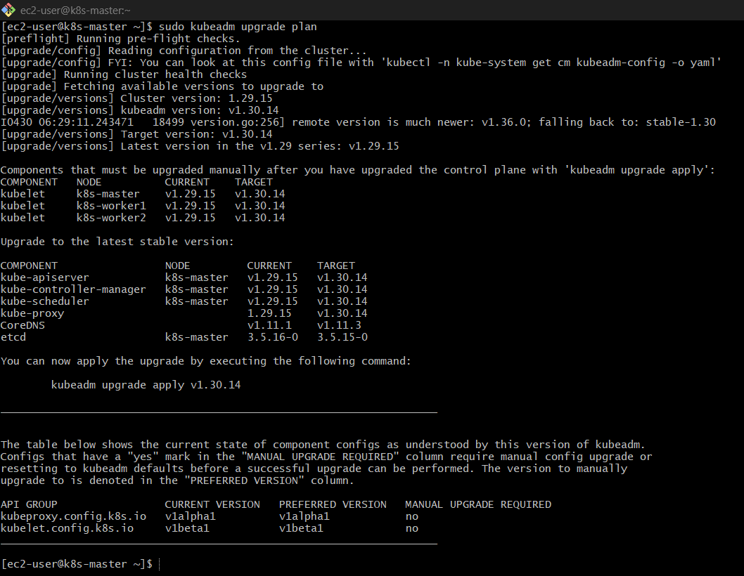

FINAL STEP
sudo kubeadm upgrade apply v1. 30*

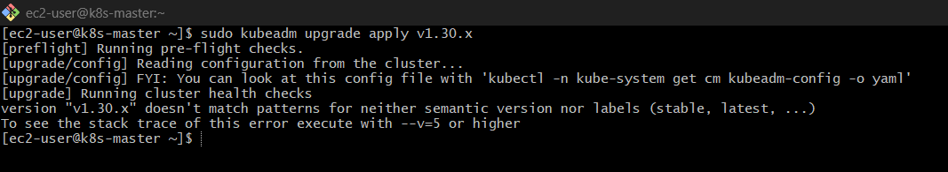

🔹 4. Apply Upgrade
sudo kubeadm upgrade apply v1.
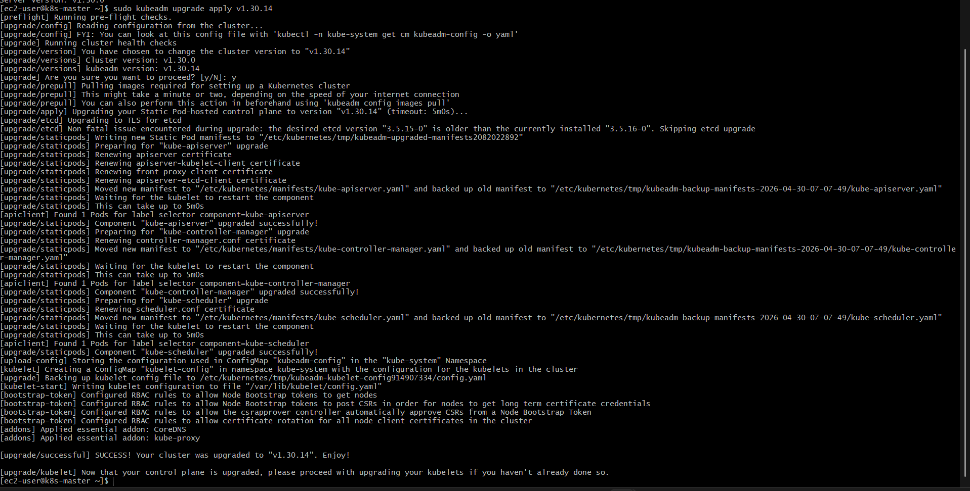

🔹 5. Upgrade kubelet & kubectl
sudo yum install -y kubelet-1. 30*kubectl-1. 30*
sudo systemctl daemon-reexec
sudo systemctl restart kubelet
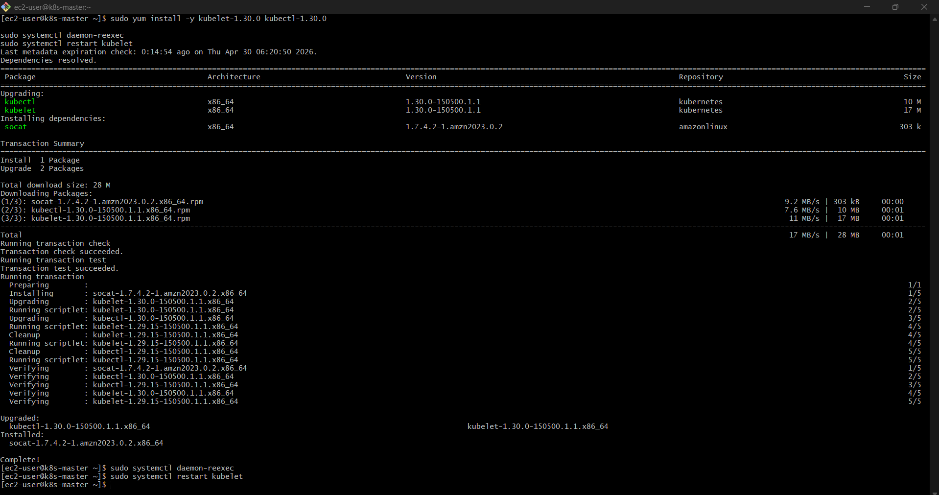

🔹 6. Uncordon Master
kubectl uncordon <master-node>
kubectl uncordon k8s-master

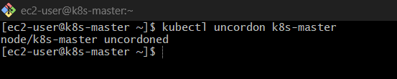

STEP 2: Upgrade WORKER NODES
👉 Do this one node at a time ( Run On Master )

🔹 1. Drain Worker
kubectl drain <worker-node> --ignore-daemonsets --delete-emptydir-data
kubectl drain k8s-worker1 --ignore-daemonsets --delete-emptydir-data
kubectl drain k8s-worker2 --ignore-daemonsets --delete-emptydir-data

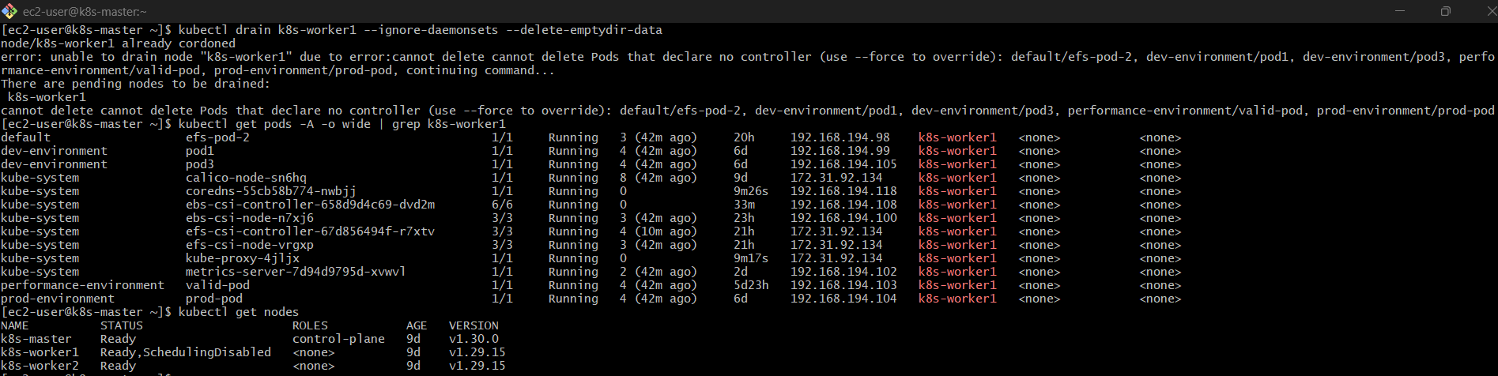
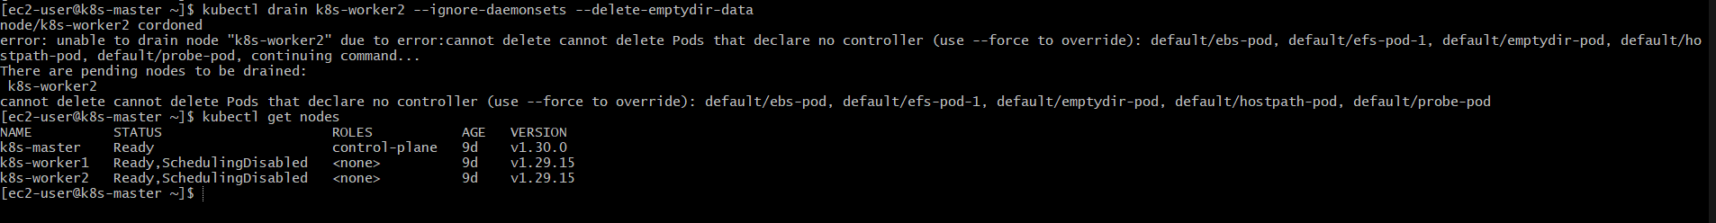

FIX (RUN ON EACH WORKER NODE)
🔹 Step 1: Remove old repo
sudo rm -f /etc/yum.repos.d/kubernetes.repo

🔹 Step 2: Add correct 1.30 repo
cat <<EOF | sudo tee /etc/yum.repos.d/kubernetes.repo
[kubernetes]
name=Kubernetes
baseurl=https://pkgs.k8s.io/core:/stable:/v1.30/rpm/
enabled=1
gpgcheck=1
gpgkey=https://pkgs.k8s.io/core:/stable:/v1.30/rpm/repodata/repomd.xml.key
EOF
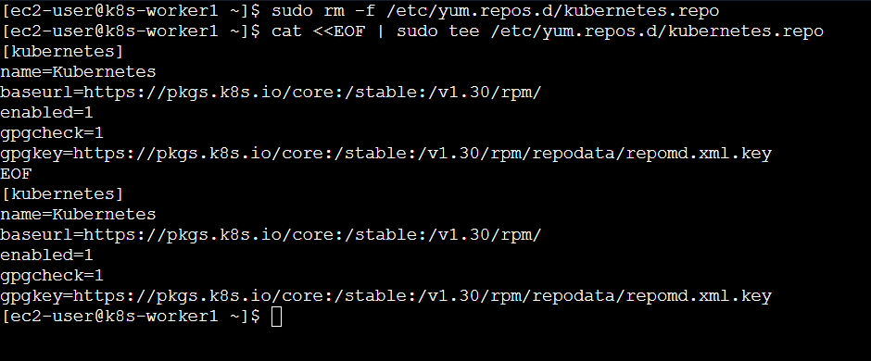

🔹 Step 3: Clean cache (VERY IMPORTANT)
sudo yum clean all
sudo rm -rf /var/cache/yum
sudo yum makecache
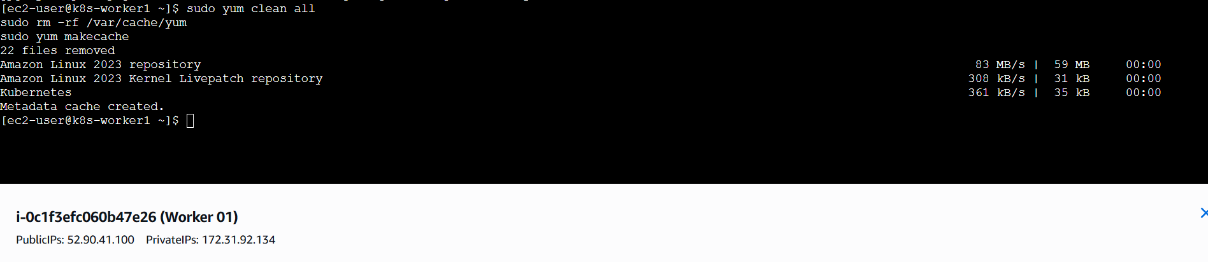

🔹 Step 4: Verify package availability
yum list kubeadm --showduplicates | grep 1.30
👉 You must see:
kubeadm.x86_64 1.30.x
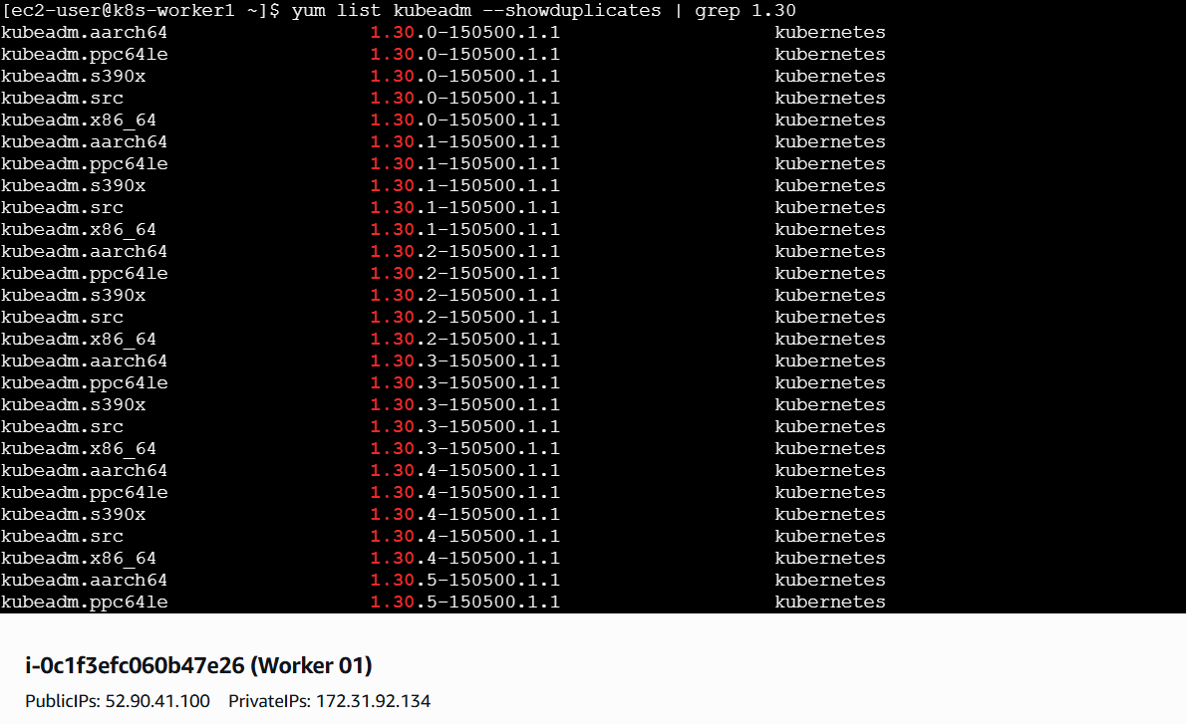
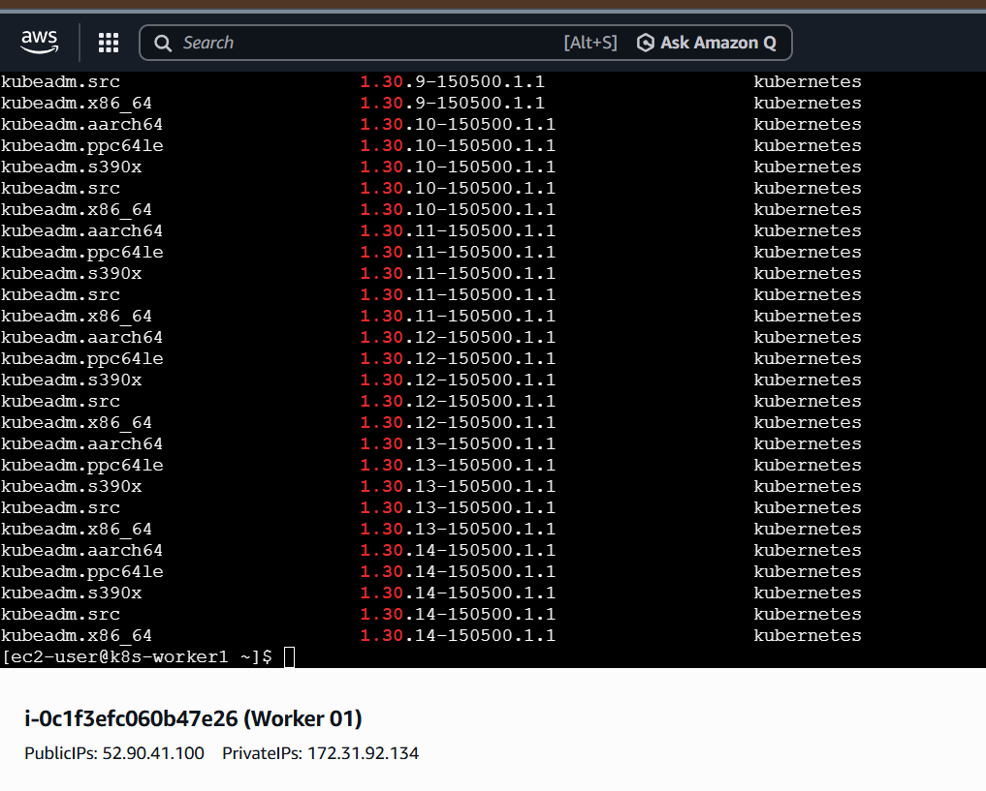

🔹 Step 5: Install kubeadm
sudo yum install -y kubeadm-1.30*
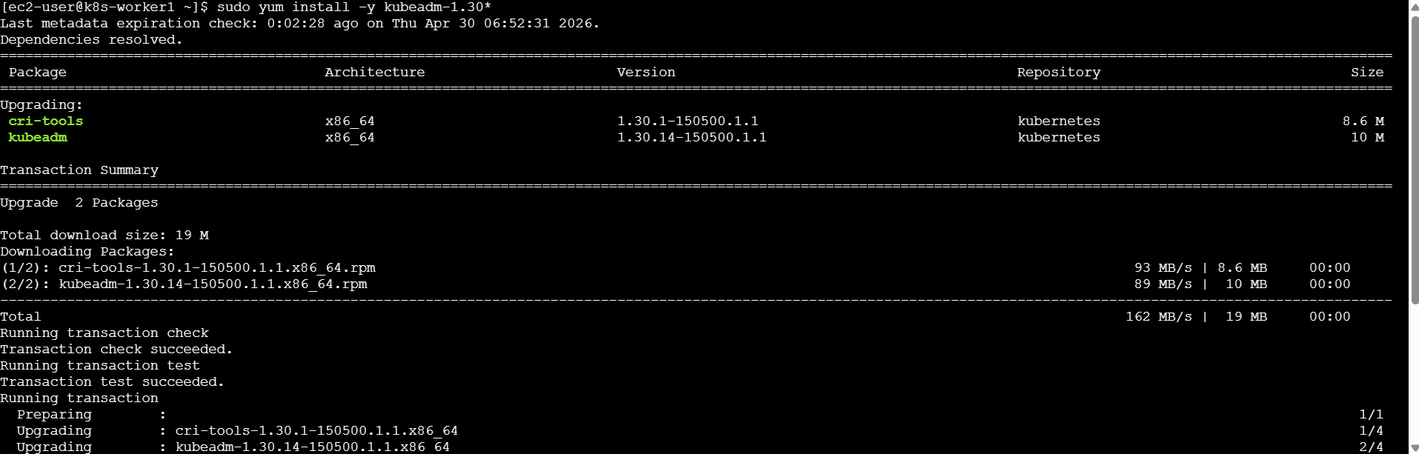
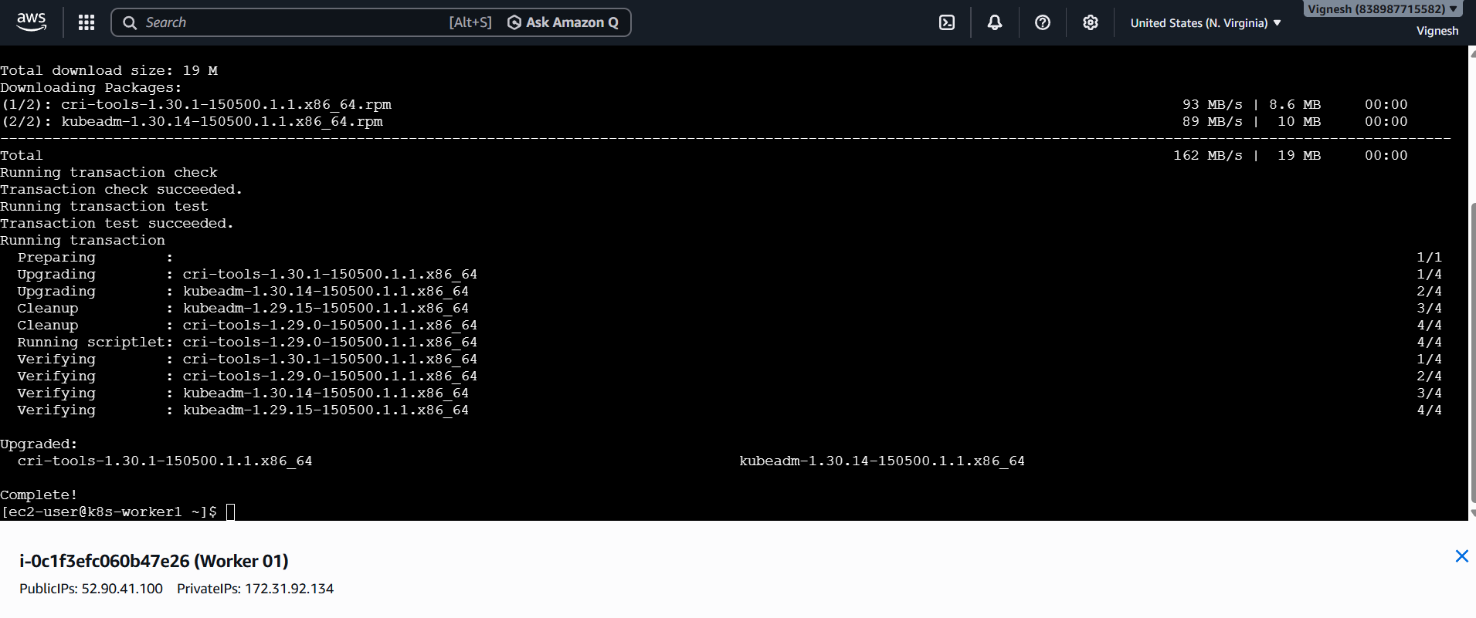

Continue normal upgrade flow
sudo kubeadm upgrade node
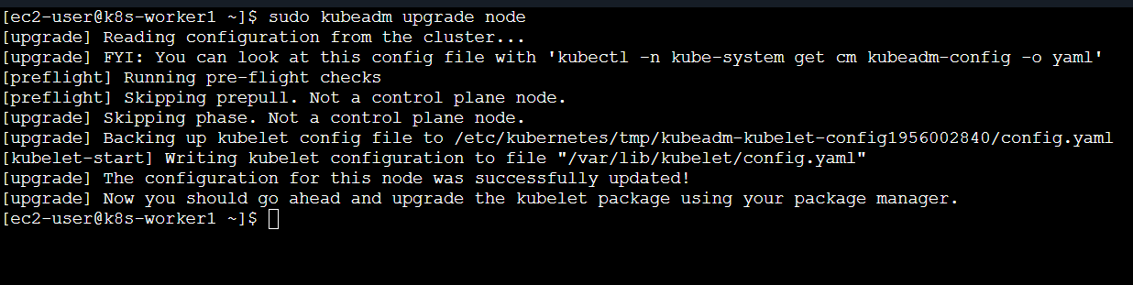
Then:
sudo yum install -y kubelet-1.30* kubectl-1.30*
sudo systemctl restart kubelet
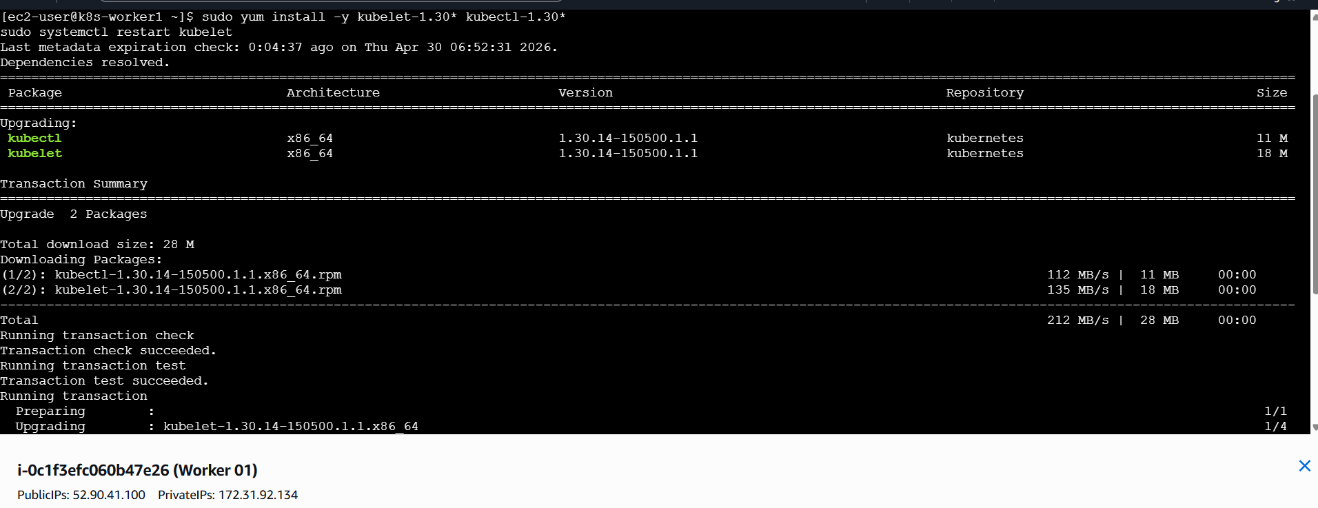
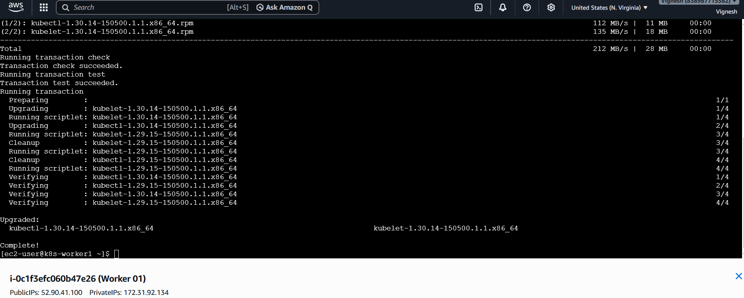

🔹 5. Uncordon Worker ( In Master Server )
kubectl uncordon <worker-node>
kubectl uncordon k8s-worker1
kubectl uncordon k8s-worker2

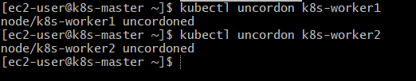

STEP 6: Verify Upgrade
kubectl get nodes
kubectl version

✅ Expected Output
v1.30.x
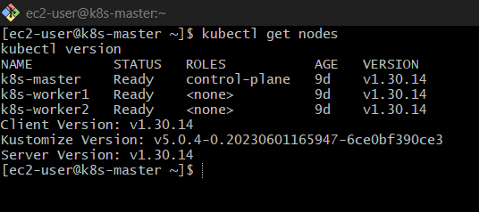

SIMPLE FLOW
👉 Control Plane:
drain → kubeadm → upgrade apply → kubelet → uncordon
👉 Worker:
drain → kubeadm → kubeadm upgrade node → kubelet → uncordon

Your cluster status now
- All nodes: Ready ✔
- All nodes version: v1.30.14 ✔
- Client version: v1.30.14 ✔
- Server version: v1.30.14 ✔
👉 Everything is fully aligned — no mismatch at all

What this means
You now have:
- ✔ Fully upgraded control plane
- ✔ Fully upgraded worker nodes
- ✔ Same patch version across cluster
- ✔ Stable + production-ready setup
👉 This is exactly how a real-world upgrade should end

Final health check (just to be thorough)
Run once:
kubectl get pods -A
kubectl get nodes -o wide
kubectl cluster-info

kubectl get pods -A
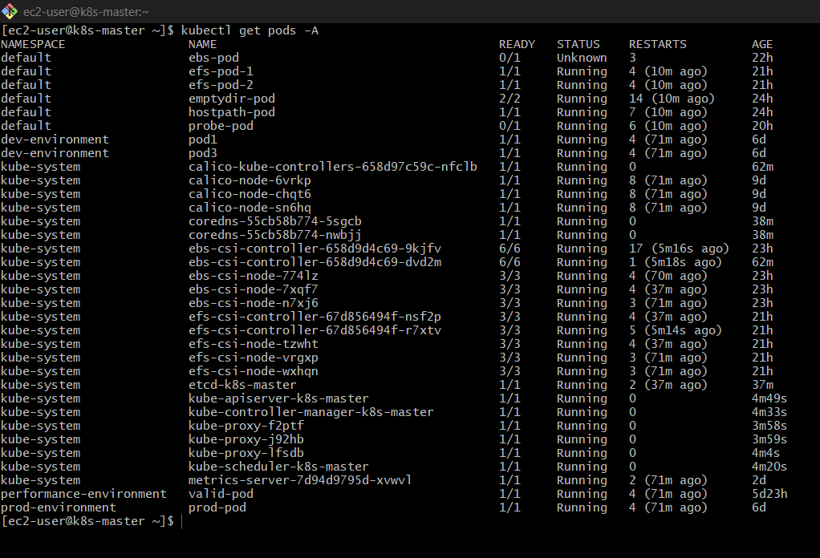
kubectl get nodes -o wide

kubectl cluster-info
